SELECT ID_MOVIMENTO FROM SAC_RV_EMPRESTIMO_ACOES WHERE NO_CONTRATO =214510 AND SG_OPERACAO ='E'

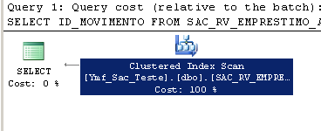

---Table 'SAC_RV_EMPRESTIMO_ACOES'. Scan count 1, logical reads 2994

Table 'SAC_RV_EMPRESTIMO_ACOES'. Scan count 1, logical reads 2

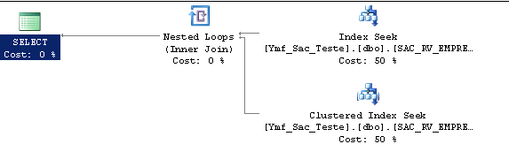

Now, I’m going to create a covering index and let’s see how the optimize works:

DROP index teste on SAC_RV_EMPRESTIMO_ACOES

create nonclustered index teste on SAC_RV_EMPRESTIMO_ACOES(NO_CONTRATO,SG_OPERACAO)
INCLUDE (ID_MOVIMENTO)

